PENETRATION TESTING REPORT

PRESENTED BY: ABDULLAH
APPROVED BY:
VERSION: 01 | DATE: 08-MAY-2025

Table of contents
1. Purpose 3
2. Summary 3
3. Project Details / Scope 3
6. Findings 3
7. Explanation 3

Purpose
Consider it like taking the University of Haripur's student portal in for a good once-over to see if there are any vulnerabilities before someone nefarious does. We essentially probed and tested it like a hacker would, so our report indicates precisely where things can be made more secure to protect everyone's data.

Summary
We conducted a web penetration test on the University of Haripur student portal to assess its security posture. The testing focused on identifying potential vulnerabilities and evaluating the overall resilience of the system against common web-based threats.

Project Details / Scope
The scope of this project was to perform a web penetration test on the University of Haripur student portal to identify security weaknesses and potential vulnerabilities. The goal was to assess the portal’s defense mechanisms and provide recommendations for improving its overall security.

Findings
Findings | Description | Details | Severity | Recommendations
SQL Injection | Database manipulation vulnerability | Unauthorized data access | Very High | Use prepared statements
Cross-Site Scripting | Client-side code injection | Malicious script injection | Very High | Sanitize user input
TLS Cookie Without Secure-Flag | Insecure cookie transmission | Vulnerable to sniffing | High | Enable Secure flag
Strict Transport Security Not Enforced | Missing HTTPS enforcement | Susceptible to downgrade | Medium | Implement HSTS header

Explanation of Findings:

SQL INJECTION
Request:
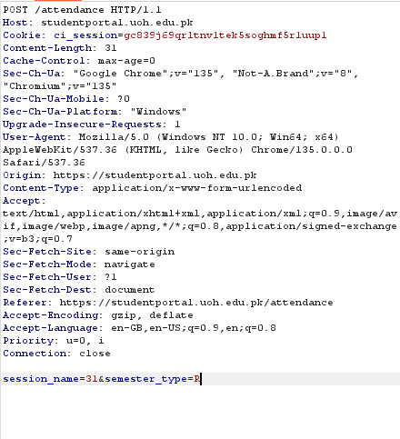
The session_name parameter is vulnerable, potentially allowing attackers to hijack or manipulate user sessions. Improper handling of this parameter can lead to session fixation or unauthorized access. Securing session management is crucial to prevent exploitation.
Request: | Output:
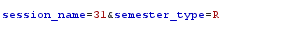 | HTTP/1.1 200 OK
 | HTTP/1.1 500 Internal Server Error

- Cross Site Scripting:
Explanation:
This issue demonstrates a classic Cross-Site Scripting (XSS) vulnerability. The application reflects user input from the URL parameter (name) directly onto the webpage without proper sanitization or encoding. An attacker can inject malicious JavaScript code through a specially crafted URL. When another user clicks on the link, the script executes in their browser, potentially allowing the attacker to steal session cookies, perform phishing, or manipulate page content. This highlights a serious security flaw where untrusted user input is not properly handled.

- TLS Cookie Without Secure Flag

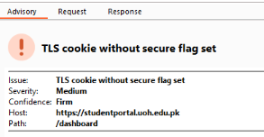
The TLS Cookie Without Secure Flag issue occurs when cookies are transmitted over both HTTP and HTTPS connections without the Secure flag set. This flag ensures that cookies are only sent over encrypted HTTPS channels. Without it, an attacker on the same network could intercept the cookie over an unencrypted HTTP connection, leading to session hijacking or unauthorized access. This weakens the overall security of user sessions, especially on public or insecure networks.

- Strict Transport Security Not Enforced

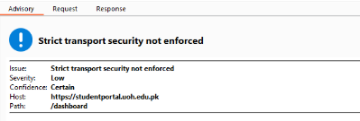
The Strict Transport Security Not Enforced issue indicates that the website does not implement the HTTP Strict Transport Security (HSTS) policy. Without HSTS, browsers may allow users to access the site over an insecure HTTP connection, making it vulnerable to man-in-the-middle (MITM) attacks and protocol downgrades. Enforcing HSTS ensures that browsers always connect to the site over HTTPS, enhancing the security of user data and communications.

